מנא מנא

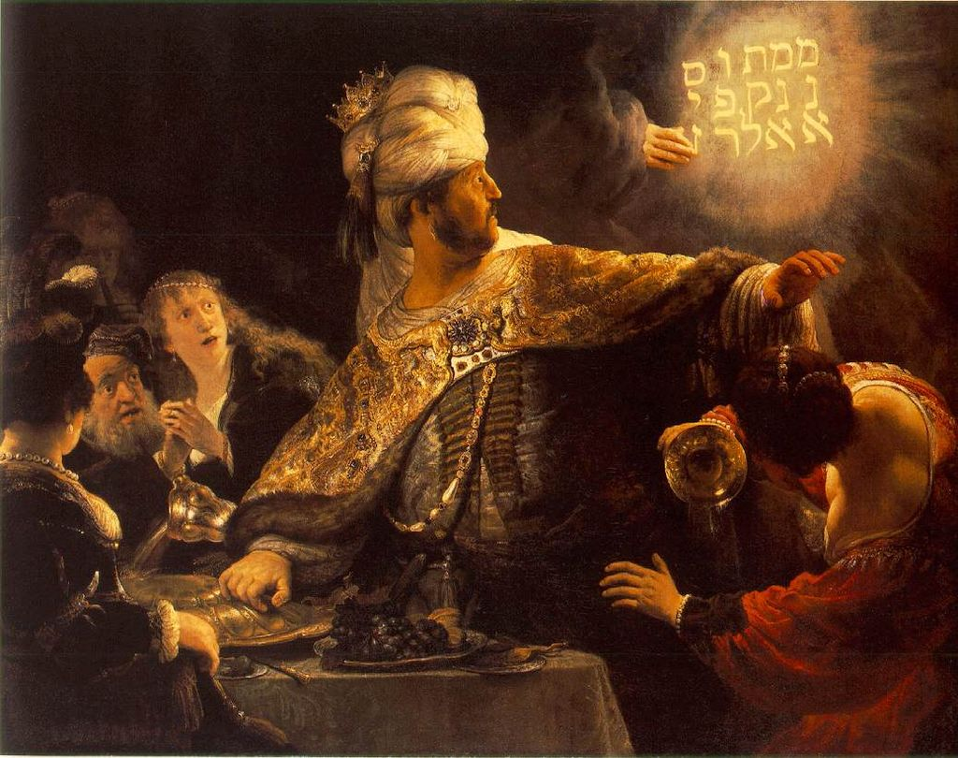

בַּהּ־שַׁעֲתָה נְפַקָה אֶצְבְּעָן דִּי יַד־אֱנָשׁ וְכָתְבָן לָקֳבֵל נֶבְרַשְׁתָּא עַל־גִּירָא דִּי־כְתַל הֵיכְלָא דִּי מַלְכָּא וּמַלְכָּא חָזֵה פַּס יְדָה דִּי כָתְבָה׃

Just then, the fingers of a human hand appeared and wrote on the plaster of the wall of the king’s palace opposite the lampstand, so that the king could see the hand as it wrote.

…  
אֱדַיִן עָלִּין כֹּל חַכִּימֵי מַלְכָּא וְלָא־כָהֲלִין כְּתָבָא לְמִקְרֵא וּפִשְׁרֵהּ לְהוֹדָעָה לְמַלְכָּא׃

Then all the king’s wise men came, but they could not read the writing or make known its meaning to the king.

…

וּדְנָה כְתָבָא דִּי רְשִׁים **מְנֵא מְנֵא תְּקֵל וּפַרְסִין**.

דְּנָה פְּשַׁר־מִלְּתָא **מְנֵא מְנָה**־אֱלָהָא מַלְכוּתָךְ וְהַשְׁלְמַהּ.

**תְּקֵל** תְּקִילְתָּה בְמֹאזַנְיָא וְהִשְׁתְּכַחַתְּ חַסִּיר.

**פְּרֵס** פְּרִיסַת מַלְכוּתָךְ וִיהִיבַת לְמָדַי וּפָרָס.

This is the writing that is inscribed: **mene mene tekel upharsin**.

And this is its meaning: **mene**—God has numbered [the days of] your kingdom and brought it to an end;

**tekel**—you have been weighed in the balance and found lacking;

**peres**—your kingdom has been divided and given to the Medes and the Persians.”

1. **Lettering - Based on Rabbi Yehuda the Prince**:  
   It is taught in a *baraita* (Tosefta 4:5): Rabbi Yehuda HaNasi says: Initially, the Torah was given to the Jewish people in this script, *Ashurit*, which is in use today. Once the Jewish people sinned, it turned into an impairment for them and they began writing with a different script, *Libona’a*. Once they repented, the first script was returned to them, and they resumed writing with *Ashurit* script, as it is stated … The *baraita* continues: If this script predates the exile to Babylonia, why is it called *Ashurit*? Because it is *meusheret*, beautiful and straight, in script.
2. **Cipher - Gematriyah:**  
   Rav says: Because it was written for them in the obscure code of gimatriyya. It was written: Yod, tet, tav; yod, tet, tav; alef, yod, dalet, khaf; peh, vav, gimmel, ḥet, mem, tet.
3. **Orientation:**  
   Shmuel says: The writing used the correct letters for those terms, but instead of being written in order, the four words, mene mene tekel ufarsin were written vertically and were therefore meant to be read from the top down.
4. **Direction:**  
   Rabbi Yoḥanan says: Each word was written backward, so that read right to left, they spelled, Anem anem leket nisrapu.
5. **Order:**  
   Rav Ashi says: They were written with the first two letters of each word reversed: Nema nema ketal pursin.

**1) Lettering**

|  |  |
| --- | --- |
| C:\Users\shlomok\AppData\Local\Microsoft\Windows\INetCache\Content.Word\MeneTekel.jpeg |  |

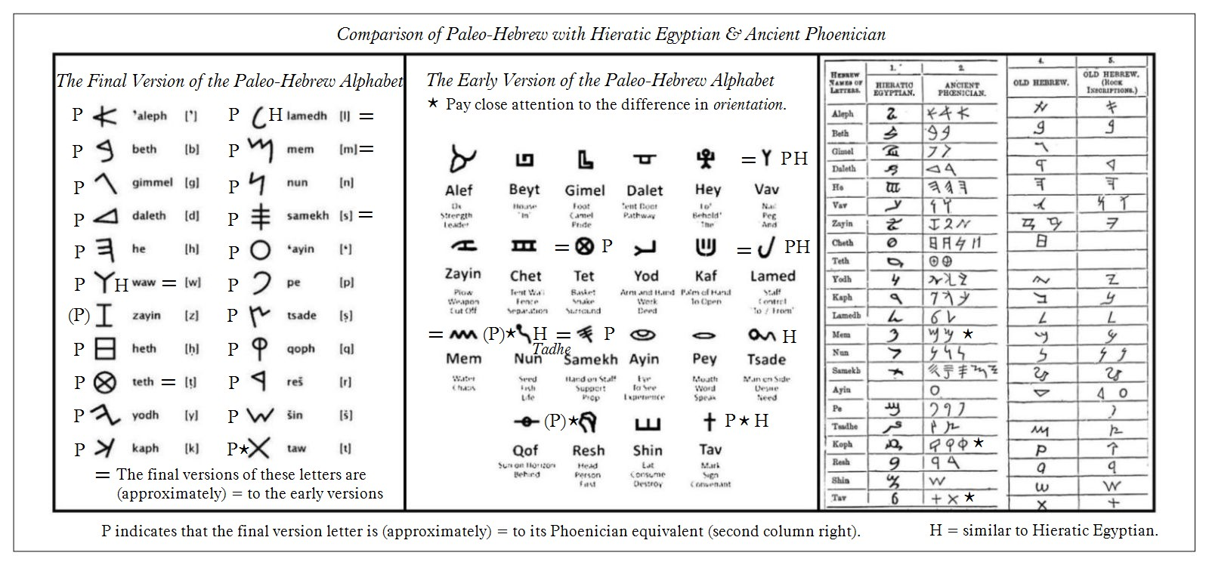

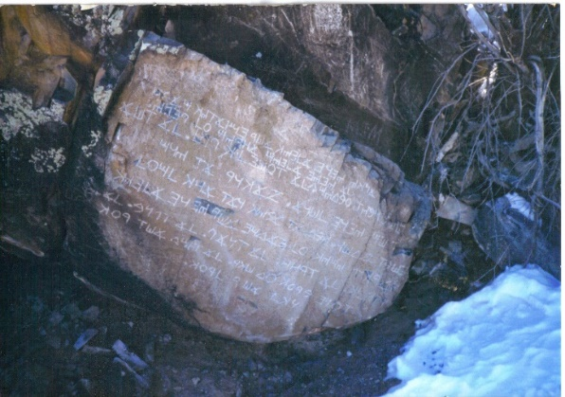

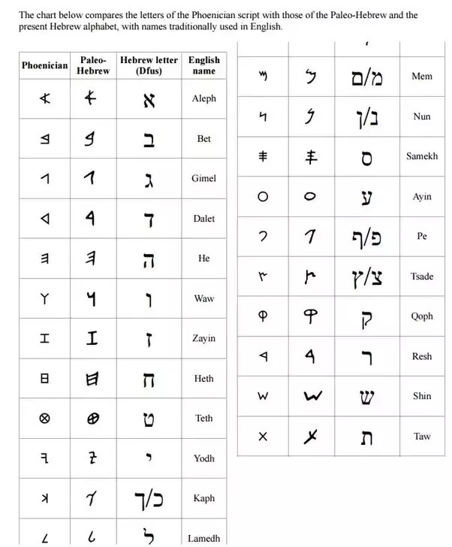

Ramban (addendum to Chumash)

**2) Cipher Gematriyahs**

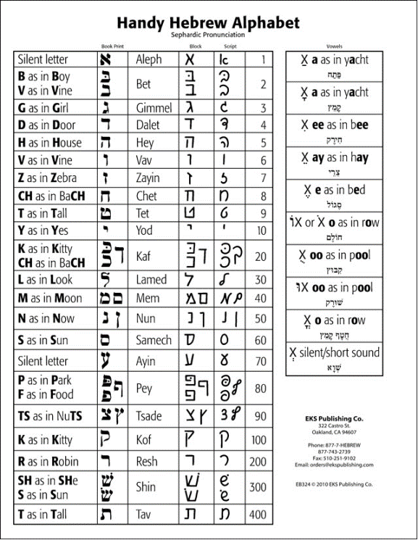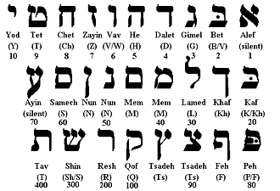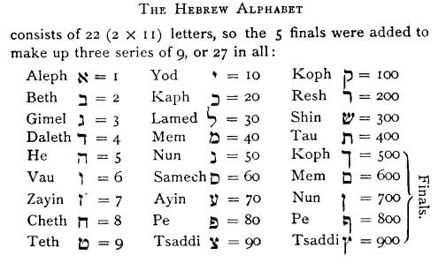

- Famous examples – Chai, 26, רדו, ונושנתם, יש, Tzitzis, Noach  
- רַבִּי אֱלִיעֶזֶר בֶּן חִסְמָא אוֹמֵר, קִנִּין וּפִתְחֵי נִדָּה, הֵן הֵן גּוּפֵי הֲלָכוֹת. תְּקוּפוֹת וְגִימַטְרִיאוֹת, פַּרְפְּרָאוֹת לַחָכְמָה  
Rabbi Eliezer ben Chisma said: the laws of mixed bird offerings and the key to the calculations of menstruation days these, these are the body of the halakhah. The calculation of the equinoxes and gematria are the appetizers of wisdom.

- Rambam Nazir 1 3 & Rosh Nazir 5a / Rashi Sukkah 28a, Ramban in his essays, Ramban intro

- Baal Haturim, Chida,

Other Gematriyahs and Tools:

1. אט בח
2. עם הכולל, עה"ט, עה"ת
3. מלוי נסתר
4. Acronyms and Last Acronyms   
   ie תנצב"ה  
   אלול –
   1. "**א**ני **ל**דודי **ו**דודי **ל**י"
   2. דברים ל' ו: "וּמָל ה' אֱלֹקיךָ **אֶ**ת-**לְ**בָבְךָ **וְ**אֶת-**לְ**בַב זַרְעֶךָ לְאַהֲבָה אֶת-ה' אֱלֹקיךָ בְּכָל-לְבָבְךָ וּבְכָל-נַפְשְׁךָ לְמַעַן חַיֶּיךָ" - פסוק ידוע ביותר מתוך פרשת התשובה בניצבים. מהות חודש אלול.
   3. בויקרא מופיע פעמים הצירוף: "**א**חד **ל**חטאת **ו**אחד **ל**עולה" ואילו בחומש במדבר מופיע: "**א**חד **ל**עולה **ו**אחד **ל**חטאת" - חטאת לכפרה על מצוות לא תעשה ועולה לכפרה על ביטול מצוות עשה.
5. את בש

|  |  |  |  |  |  |  |  |  |  |  |  |  |  |  |  |  |  |  |  |  |  |  |  |  |  |  |
| --- | --- | --- | --- | --- | --- | --- | --- | --- | --- | --- | --- | --- | --- | --- | --- | --- | --- | --- | --- | --- | --- | --- | --- | --- | --- | --- |
| **Plain** | A | B | C | D | E | F | G | H | I | J | K | L | M | N | O | P | Q | R | S | T | U | V | W | X | Y | Z |
| **Cipher** | Z | Y | X | W | V | U | T | S | R | Q | P | O | N | M | L | K | J | I | H | G | F | E | D | C | B | A |

|  |  |  |  |  |  |  |  |  |  |  |  |  |  |  |  |  |  |  |  |  |  |  |
| --- | --- | --- | --- | --- | --- | --- | --- | --- | --- | --- | --- | --- | --- | --- | --- | --- | --- | --- | --- | --- | --- | --- |
|  | Aleph | Bet | Gimel | Daleth | Heh | Vav | Zayin | Het | Tet | Yodh | Kaph | Lamed | Mem | Nun | Samech | Ayin | Peh | Tzady | Koof | Reish | Shin | Taw |
| **Plain** | א | ב | ג | ד | ה | ו | ז | ח | ט | י | כ | ל | מ | נ | ס | ע | פ | צ | ק | ר | ש | ת |
|  | Taw | Shin | Reish | Koof | Tzady | Peh | Ayin | Samech | Nun | Mem | Lamed | Kaph | Yodh | Tet | Het | Zayin | Vav | Heh | Daleth | Gimel | Bet | Aleph |
| **Cipher** | ת | ש | ר | ק | צ | פ | ע | ס | נ | מ | ל | כ | י | ט | ח | ז | ו | ה | ד | ג | ב | א |

**יטת יטת אידך פוגחמט**

- Maharal on Brachos 4b

If Pesach falls on a Sunday, you can use את בש for the rest of the holidays:

א = תשעה באב, ב=שבועות, ג=ראש השנה, ד=קריאת התורה, ה=צום כיפר (צום גדליהו)

ו=פורים (קודם) ע=עצמות

**3) Orientation**

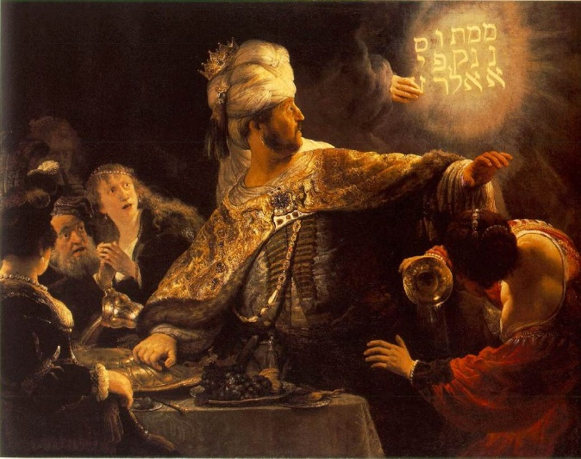

Rav Saadia Gaon, Maharsha (See Maharshal who understands Shmuel’s opinion differently)

**4) Direction**

**אנם אנם לקת ניסרפו**

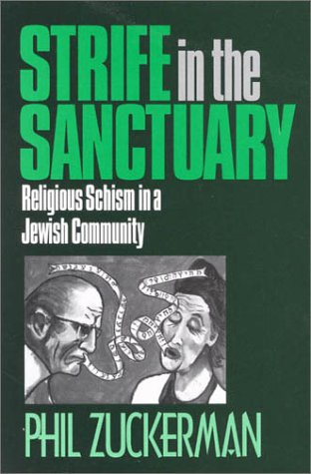

**5) Order**

**נמא נמא קתל פורסין**

פר

ת ש ר ק ץ ף ע ס ן ם ל ך י ט ח ז ו ה ד ג ב א